

Jarvis Consulting

Linux Cluster Monitoring
Project #: 01
Business Requirements Document (BRD)

Prepared by: | Dhwani Agrawal
Prepared for: | Jarvis Consulting
Date Submitted:
Document Number: | 2026-02/01/BRD
Security Classification: | Low
Version: | 1.0
Last Updated:
Creation Date: | Feb 27, 2026

Table of Contents

1. Executive Summary 3
2. Project Objectives 3
3. Needs Statement 3
4. Project Scope 4
5. System Architecture 4
6. Key Technical Features 6
7. Business Requirements 6
8. Key Stakeholders 7
9. Schedule and Milestones 7
10. Cost-Benefit Analysis 8
11. Conclusion 8

Executive Summary

This document outlines the business requirements for the Linux Cluster Monitoring Agent project. The purpose of this initiative is to design and implement a centralized monitoring solution capable of collecting, storing, and analyzing hardware specifications and real-time resource utilization metrics across Linux servers within the organization’s cluster environment.
The organization currently lacks a standardized and automated mechanism to monitor CPU and memory utilization across servers in the data center. This gap limits visibility into infrastructure performance and complicates hardware planning decisions. The proposed solution introduces lightweight monitoring agents deployed on each Linux host to collect system metrics and store them in a centralized PostgreSQL database. The collected data will support reporting, analytics, and proactive operational decision-making.
The system will be evaluated, developed, tested, and deployed before the end of the February 2026. Key stakeholders include the Project Manager, Linux Cluster Administration (LCA) team, Implementation/Agile team, and Support team. This document defines the objectives, scope, requirements, stakeholders, timeline, and cost-benefit justification for the project.

Project Objectives

The primary objective of this project is to implement a centralized Linux cluster monitoring system that enables real-time visibility into server resource utilization for planning and operational purposes.
The solution must be deployed across all production Linux servers within the cluster environment by March 30, 2026. The system must collect CPU and memory usage metrics at regular intervals and store them in a centralized database with data retention policies defined by the LCA team. The solution must generate daily usage reports before 6:00 PM and provide threshold-based alerts when CPU or memory utilization exceeds predefined limits, such as 90%. The monitoring platform must operate with minimal performance overhead and maintain at least 99% data collection reliability.
Successful implementation will provide measurable improvements in infrastructure visibility, capacity planning accuracy, and operational responsiveness. The project aligns with the organization’s strategic objective of improving infrastructure efficiency and reducing unnecessary capital expenditure on hardware resources.
Additionally, the project aims to establish a foundation for future monitoring enhancements, including network performance tracking, disk I/O monitoring, and predictive analytics capabilities. By implementing this solution using lightweight Bash scripts and containerized infrastructure, we ensure minimal performance impact on monitored systems while maintaining scalability for future cluster expansion.

Needs Statement

The Linux Cluster Administration team requires consistent and reliable insight into server hardware utilization in order to make informed infrastructure planning decisions. Currently, monitoring activities are either manual, inconsistent, or insufficiently centralized, resulting in reactive management rather than proactive planning.
Without accurate and timely resource usage data, the organization risks overprovisioning hardware, which increases operational costs, or under provisioning, which may lead to performance degradation and service disruption. Additionally, the absence of automated alerting mechanisms increases the risk of delayed response to server overload or downtime incidents.
Implementing a centralized monitoring solution will enable the LCA team to track utilization trends, identify overloaded or underutilized servers, and optimize cluster resource allocation. Automated alerts will ensure timely intervention in the event of abnormal resource consumption or system failure. This project addresses both operational efficiency and financial optimization needs.

Project Scope

Scope management ensures that the project delivers the required functionality while preventing scope creep and unnecessary complexity. The Linux Cluster Monitoring Agent project will focus on the implementation of a monitoring solution designed to collect, store, and analyze CPU and memory usage data across Linux servers.
The project includes evaluating and selecting appropriate technologies for metric collection, database storage, and reporting. It includes developing and deploying monitoring agents on Linux hosts, configuring a centralized PostgreSQL database, implementing automated data collection through scheduled cron jobs, and validating data accuracy across development, testing, pre-production, and production environments. The project also includes providing documentation and conducting knowledge transfer sessions for the Support and LCA teams.
The project does not include monitoring of network traffic, disk I/O performance beyond basic requirements, or integration with enterprise-grade commercial monitoring platforms. It does not involve replacing existing infrastructure management systems or redesigning data center architecture. Advanced predictive analytics or AI-based anomaly detection is outside the scope of this phase.

System Architecture

The system follows a three-layer architecture.
1. Data Collection Layer
Linux Monitoring Agents installed on cluster nodes collect system metrics.
Responsibilities:
- Collect hardware details (CPU, RAM, disk)
- Collect runtime metrics
- Schedule periodic monitoring tasks
- Send collected data to central server
Tools used:
- Python scripts
- Linux system commands
2. Processing Layer
The central monitoring service receives data from agents and processes it before storing it in the database.
Responsibilities:
- Receive monitoring data from agents
- Validate incoming data
- Process and structure system metrics
- Store processed data into database
3. Data Storage Layer
Monitoring data is stored in a relational database for analysis and reporting.
Responsibilities:
- Store historical monitoring data
- Maintain host configuration information
- Support querying and reporting
Database:
- PostgreSQL / MySQL / SQL Server
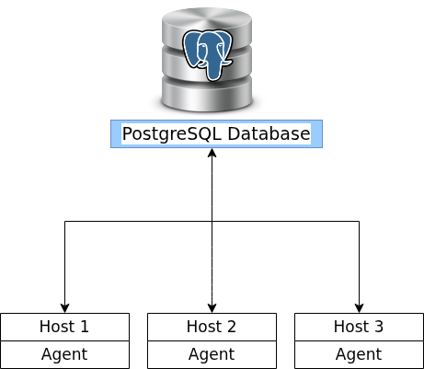
High level Data Flow
- Monitoring agent runs on Linux server.
- Agent collects system performance metrics.
- Metrics are sent to the central monitoring service.
- The service processes the data.
- Data is stored in the monitoring database.
- Administrators access reports and dashboards.

Key Technical Features

Automated Monitoring
Monitoring agents run on a scheduled basis to automatically collect system metrics without manual intervention.
Real-Time System Metrics Collection
The system captures real-time metrics including:
- CPU usage
- Memory usage
- Disk utilization
- System uptime
- Host configuration information
Centralized Monitoring
All cluster nodes send monitoring data to a central database allowing administrators to monitor system health across the entire cluster from a single location.
Historical Data Storage
Monitoring data is stored in the database to allow:
- Trend analysis
- Performance monitoring
- Historical system performance reporting

Business Requirements

The system must include an agent-based program installed on each Linux server to collect static hardware specifications and dynamic resource usage metrics. Static data must include CPU architecture, CPU core count, CPU speed, cache size, and host identification details. Dynamic data must include CPU utilization percentage, memory utilization percentage, and timestamp of data collection.
All collected data must be stored in a centralized relational database management system, specifically PostgreSQL, deployed within a Docker container environment. The database must ensure data integrity, secure access, and reliable storage with appropriate indexing to support query performance.
The system must support automated data collection at fixed intervals using cron scheduling. Data collection scripts must execute successfully without manual intervention and must log execution status for troubleshooting purposes.
The solution must support analytics and reporting through structured SQL queries capable of identifying high-usage hosts, historical usage trends, and cluster-wide utilization summaries. Daily usage reports must be generated and made available before 6:00 PM local time. The system must also support threshold-based alerting to notify the LCA team when CPU or memory utilization exceeds predefined limits or when a host becomes unreachable.
The solution must maintain operational reliability and introduce minimal overhead on host performance. Security best practices must be followed for database authentication and container management.

Key Stakeholders

The Project Manager is responsible for overall coordination, timeline adherence, and ensuring that all stakeholders meet their commitments. The Project Manager will monitor progress and manage risks throughout the project lifecycle.
The Linux Cluster Administration (LCA) team represents the business stakeholders. This team is responsible for defining business requirements, specifying reporting needs, setting service-level expectations, and approving final deliverables. The LCA team will also be responsible for funding implementation and maintenance activities.
The Implementation/Agile team is responsible for system design, development, configuration, and testing. This team includes a Scrum Master, Product Owner, Business Systems Analyst (BSA), developers, and a QA analyst. The BSA will document requirements and ensure traceability between business needs and technical implementation.
The Support team is responsible for deploying the monitoring agents across the cluster environment and managing ongoing operational support. This includes version upgrades, monitoring system health, troubleshooting incidents, and providing Level 2 support.
No additional full-time resources are anticipated for this project; however, cross-functional collaboration between teams is required.

Schedule and Milestones

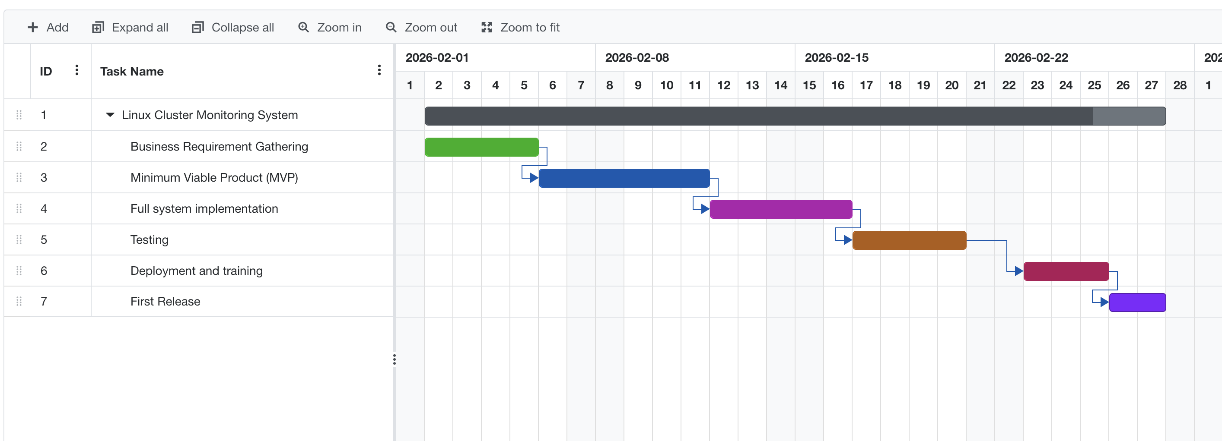
Figure 1 Gnatt Chart For Timeline

Business requirements gathering will be completed by February 5, 2026. Development of a Minimum Viable Product (MVP) will be completed by February 11, 2026. Full system implementation will be finalized by February 16, 2026.
Testing across development, quality control, pre-production, and production environments will be completed by February 20, 2026. Deployment to production will occur by February 25, 2026. Knowledge transfer sessions with the LCA team will be completed by February 25, 2026. The first official daily usage report and alert cycle will be delivered by February 27, 2026.
Timeline risks include technical configuration challenges, deployment delays across large server clusters, and potential infrastructure compatibility issues. Mitigation strategies include phased deployment and early testing.

Cost-Benefit Analysis

The costs associated with this project include development time, testing efforts, infrastructure configuration, and ongoing maintenance. There may also be indirect costs associated with training, documentation preparation, and deployment coordination.
However, the benefits significantly outweigh these costs. The system will reduce manual monitoring effort, minimize the risk of hardware overprovisioning, and prevent performance degradation due to underutilization or overload. Accurate resource visibility enables data-driven hardware procurement decisions, potentially reducing unnecessary capital expenditure.
The monitoring system will also reduce downtime risk through proactive alerting, thereby minimizing opportunity costs associated with service disruptions. Over time, improved resource planning and automation will generate operational savings and enhance infrastructure reliability.

Conclusion

The Linux Cluster Monitoring Agent project provides a structured and scalable solution for centralized server monitoring. By implementing automated data collection, centralized storage, and actionable reporting, the organization will gain improved visibility into infrastructure utilization and strengthen its capacity planning processes.
This initiative aligns with business goals of operational efficiency, cost optimization, and infrastructure reliability. Upon approval, the project will proceed according to the defined schedule and stakeholder responsibilities.

